**Folder Description:**

Files attached are:

1. MultimediaAssignment.jar

To run the jar:

1.please go to the directory path where jar is placed.

2. run **java –jar MultimediaAssignment.jar**

**OR**

3. Try double clicking the jar file

1. MultimediaAssignment2 Folder with Java Code files. All changes are done in CBIR.java file
2. Assignment2_Report

**Steps to execute once jar is running:**

1. A webpage will be displayed as shown below:

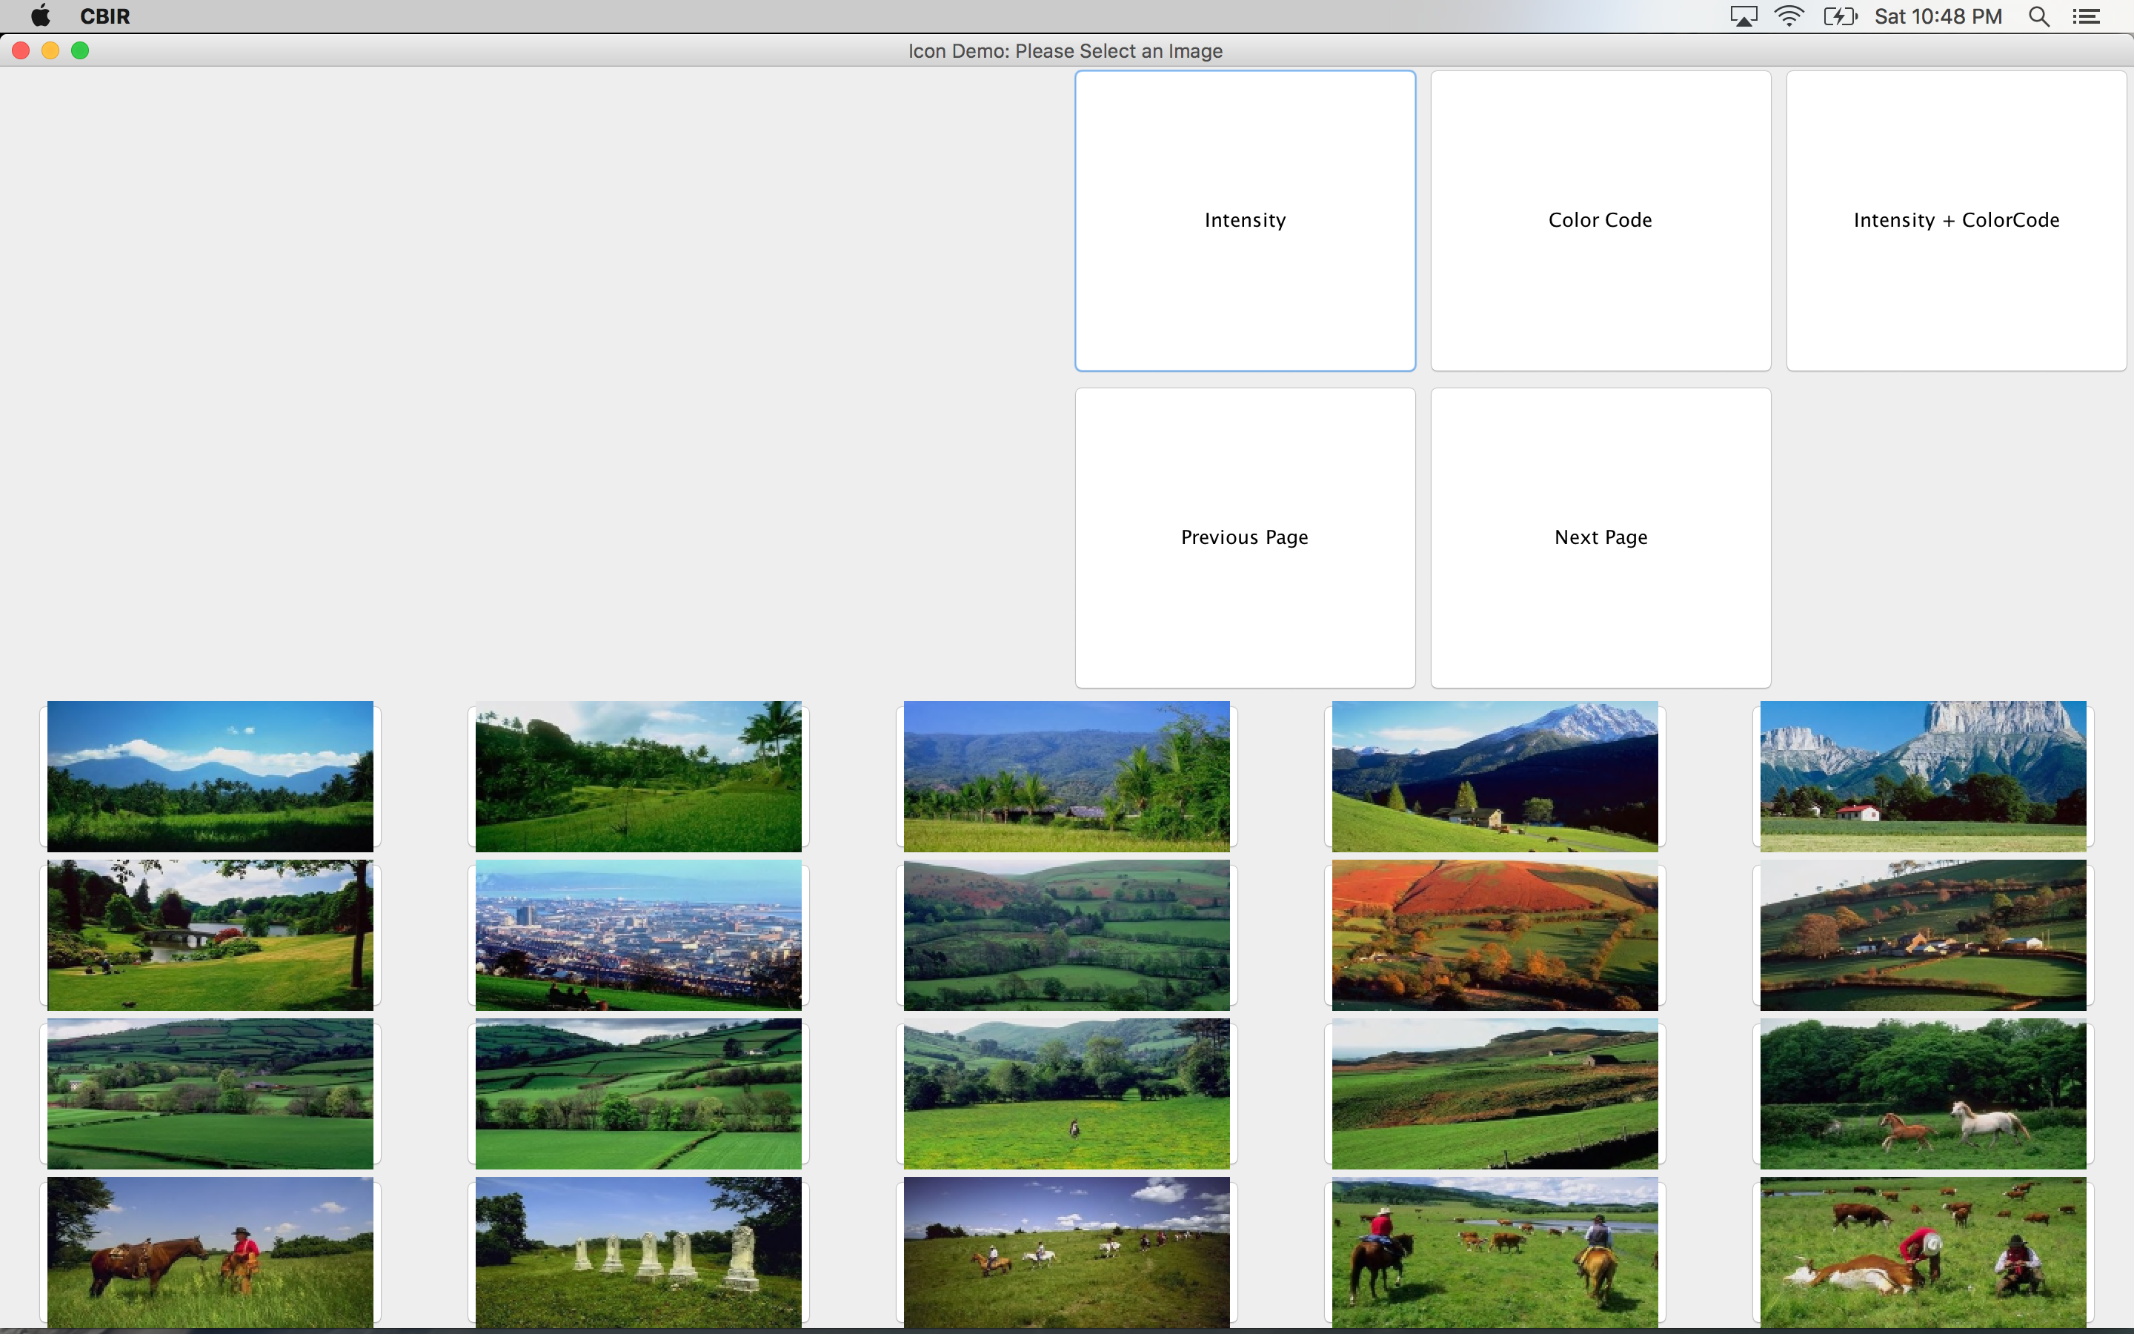

1. Select any image by clicking on it.

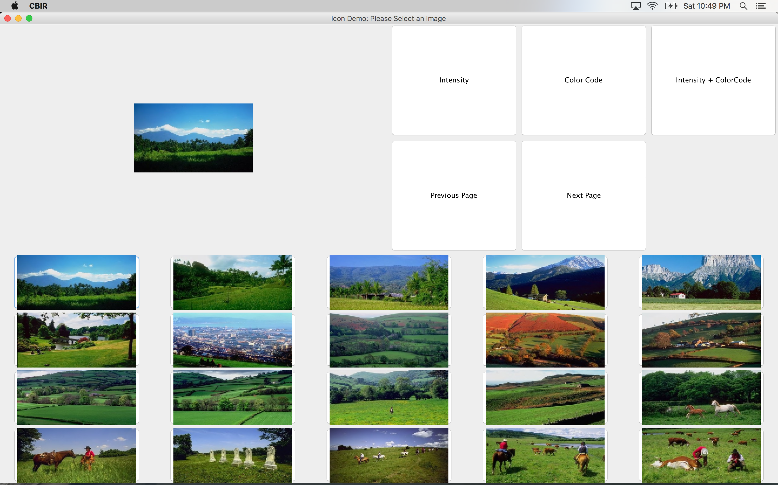

1. Select “Intensity + ColorCode” button. This button will retrieve a set of images based on Intensity plus color code feature method or Relevance feedback algorithm. This first set of images are retrieved using default weight value i.e. 1/89. Please note relevance check will only appear when “Intensity+ColorCode” algorithm is applied.

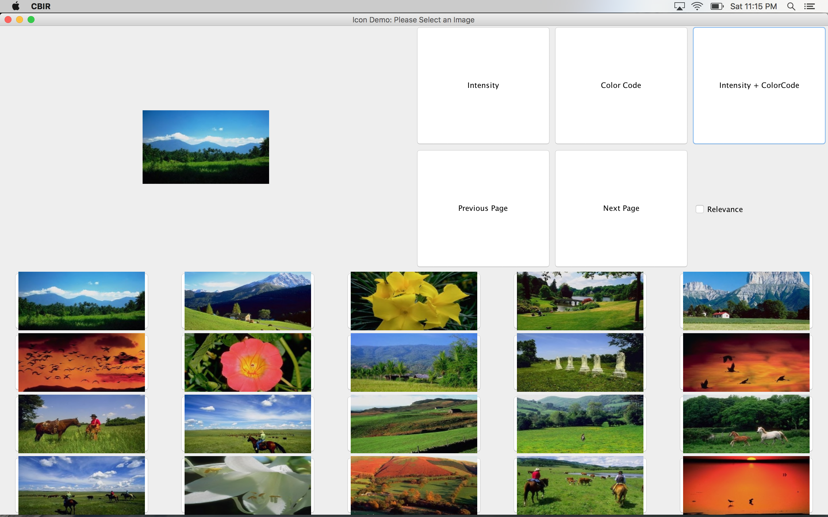

1. Check the relevence button. A “Relevant” check button will appear below every image

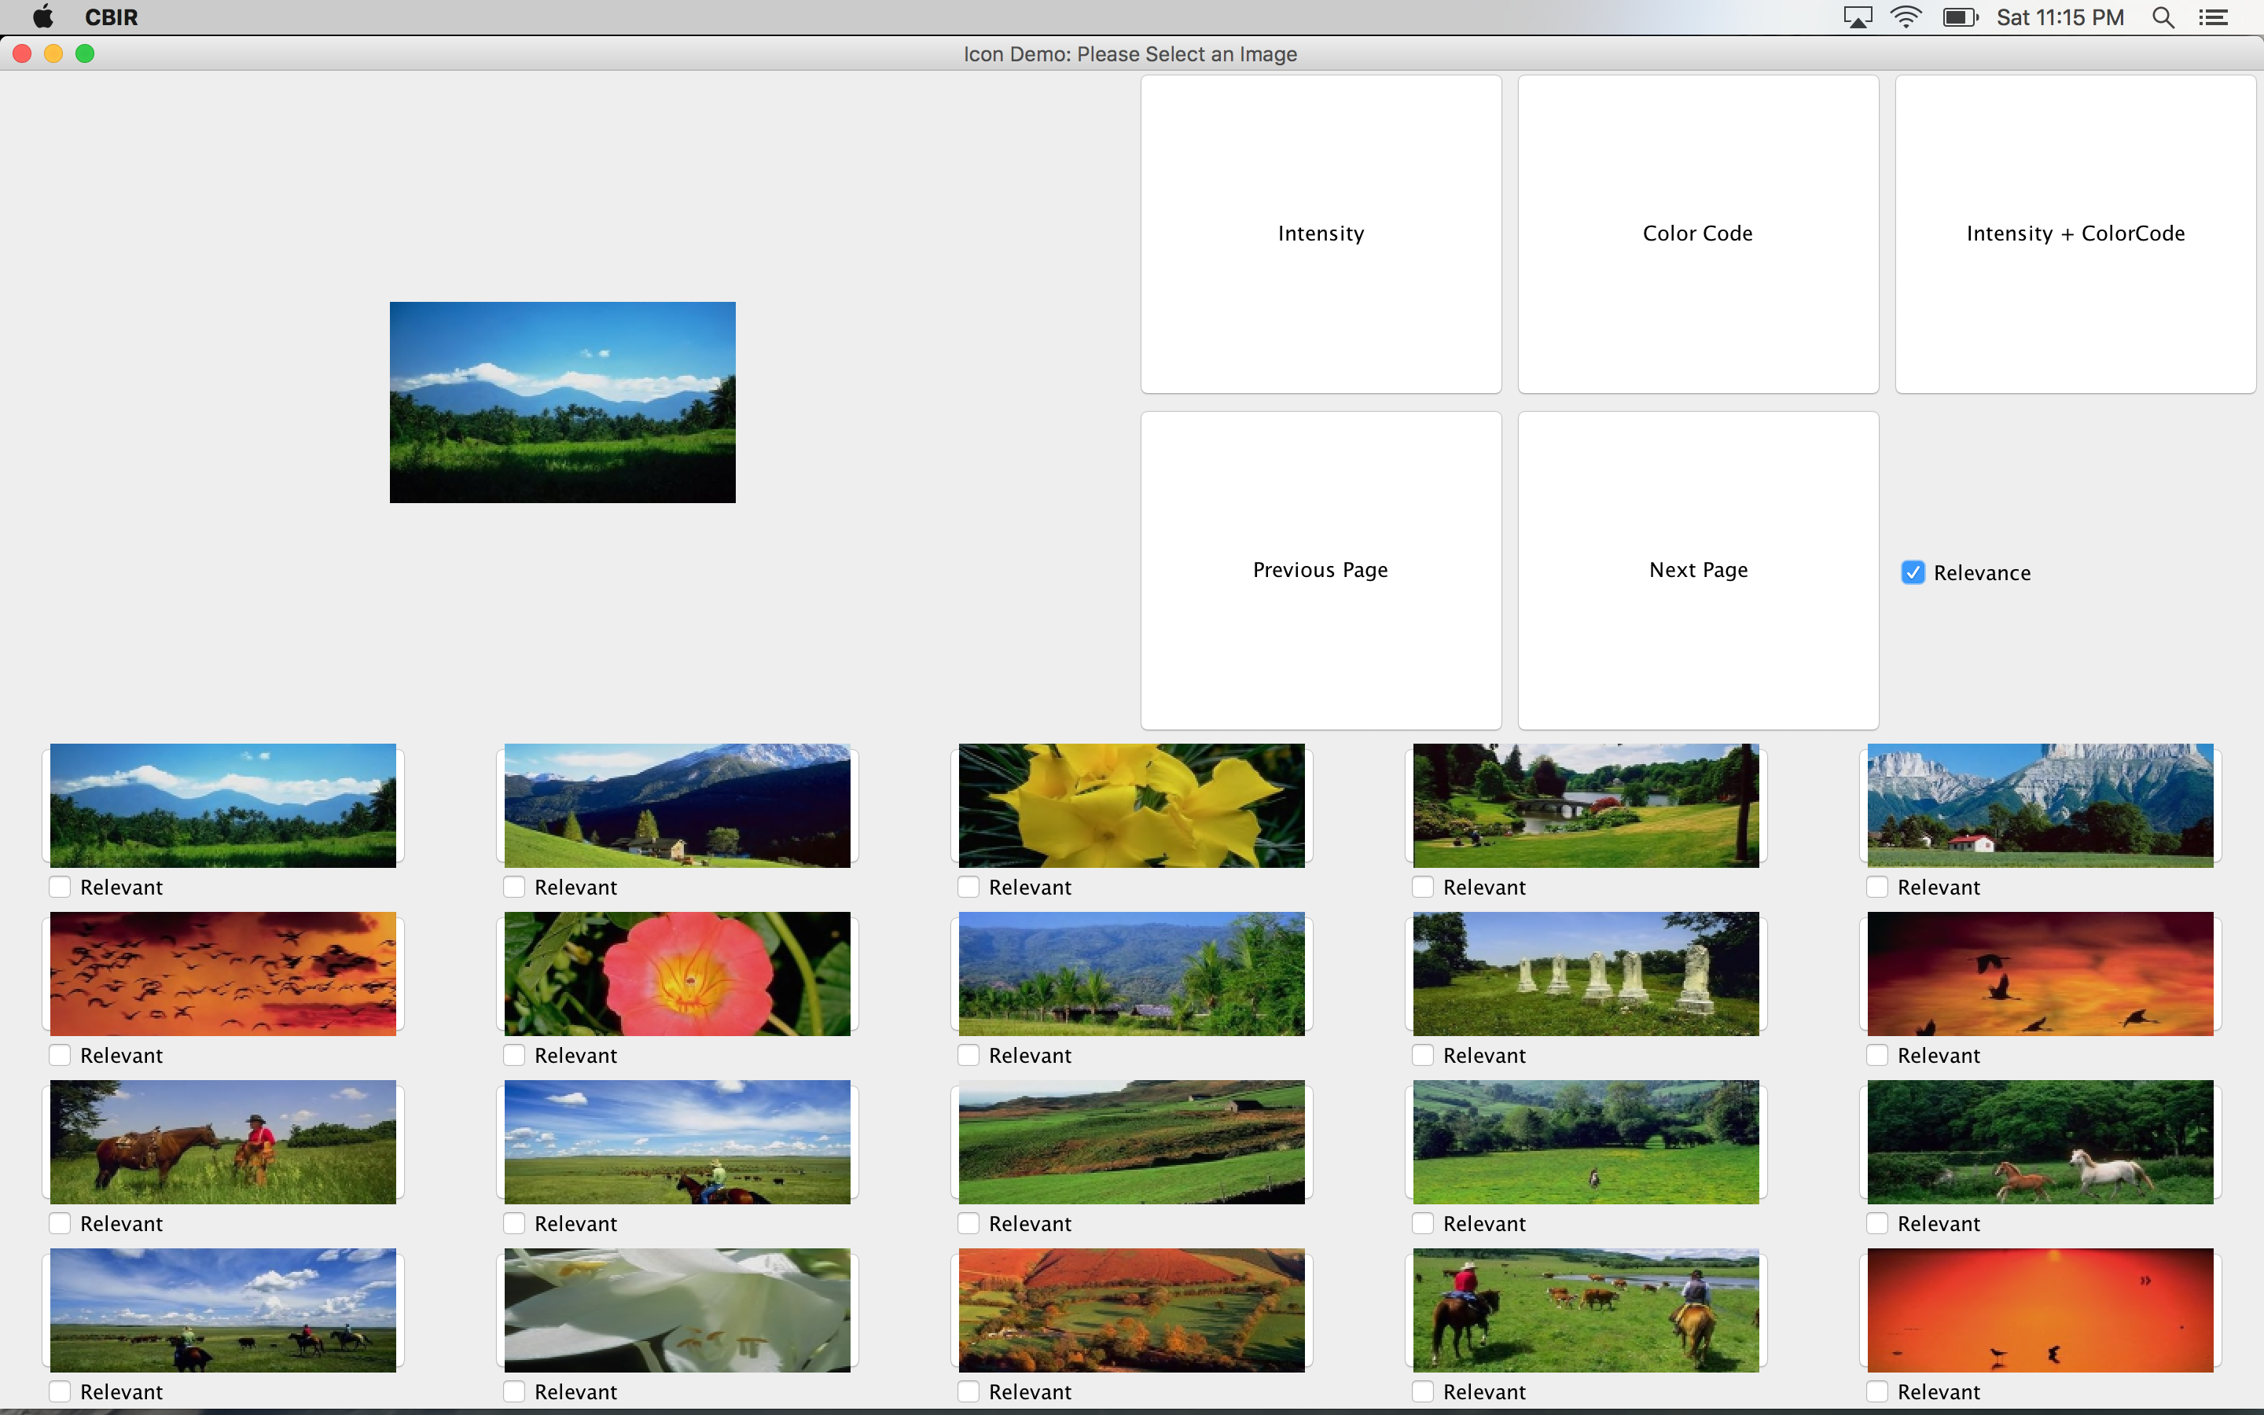

1. Select the checkbox under the images that are relevant. For example, as shown in the images below and click on the “Intensity + ColorCode” button. **This will be The First iteration.**

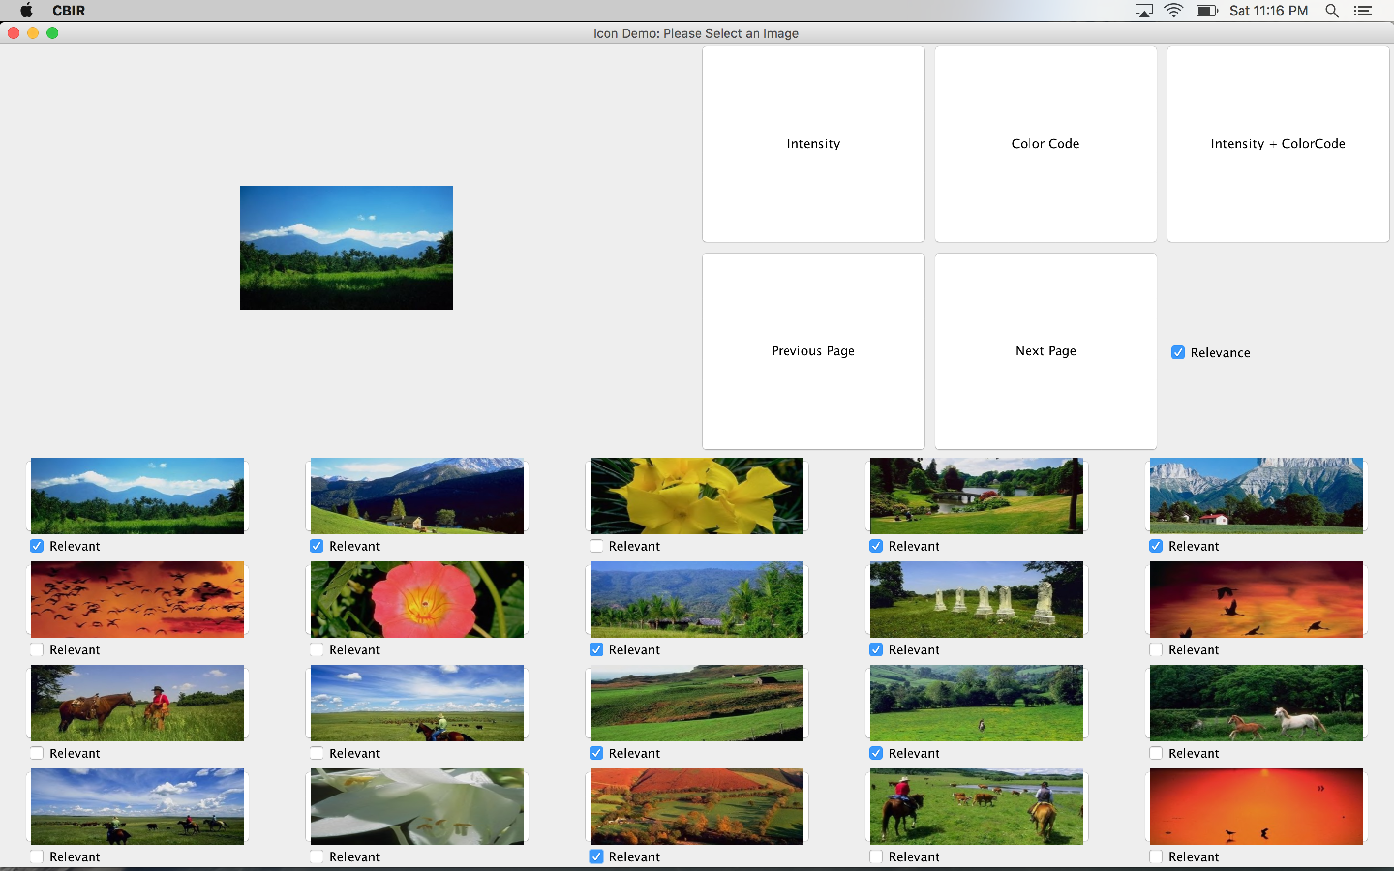

1. A new set of images will be displayed that looks more relevant to the selected image. The images that were checked in previuosly will come with the checks on. We can check few more relevant images and click on the “Intensity + ColorCode” button. This will be **The second iteration**.

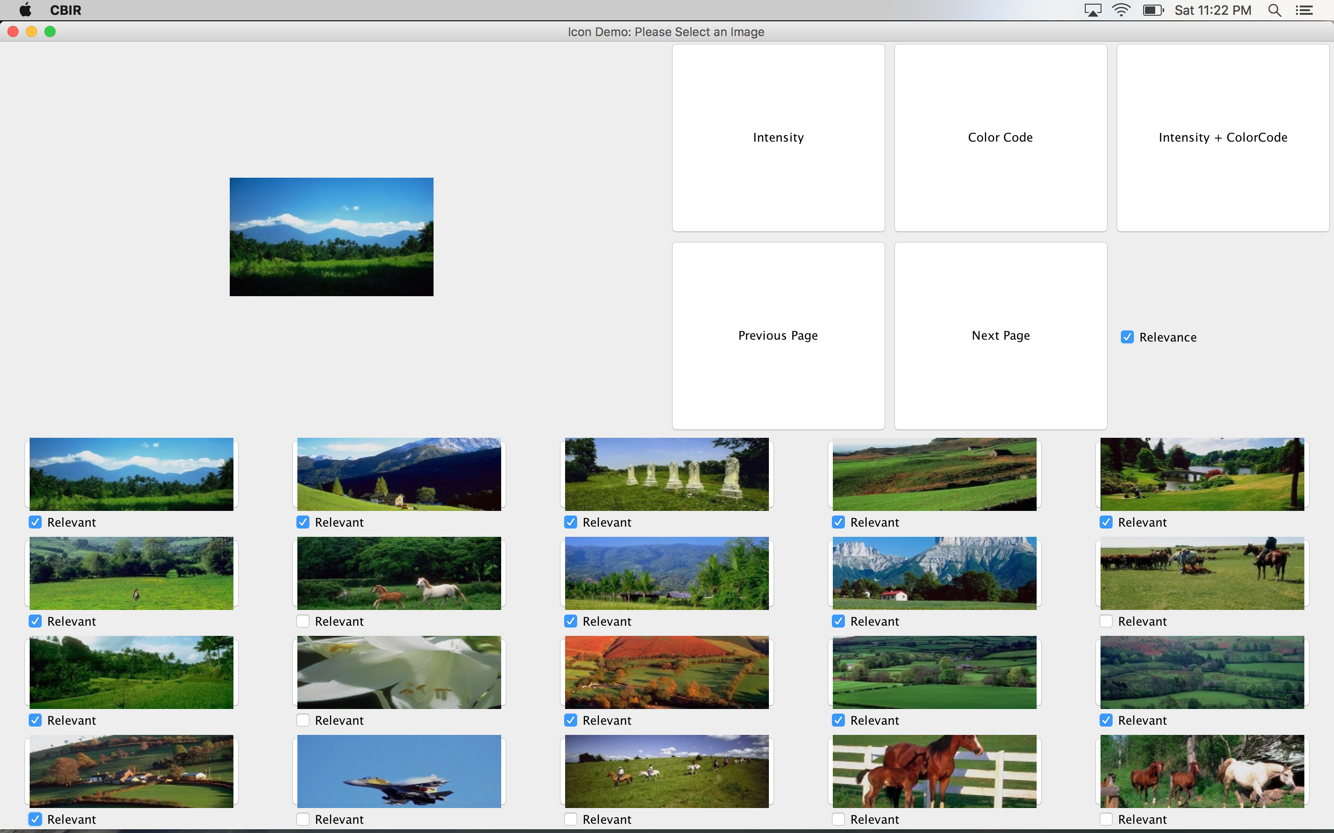

1. A new set of images will be displayed that looks more relevant to the selected image. The images that were checked in previuosly will come with the checks on. We can check few more relevant images and click on the “Intensity + ColorCode” button. This will be **The Third iteration**.

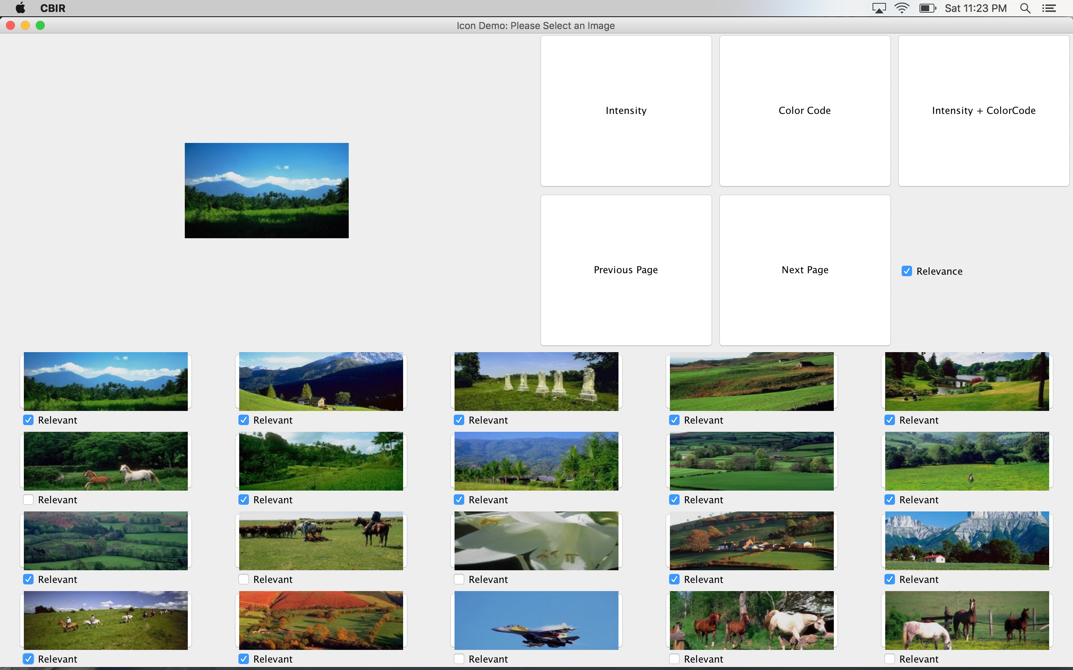

1. The result set after third iteration will be as shown below. We can continue the iterations as long as we want.

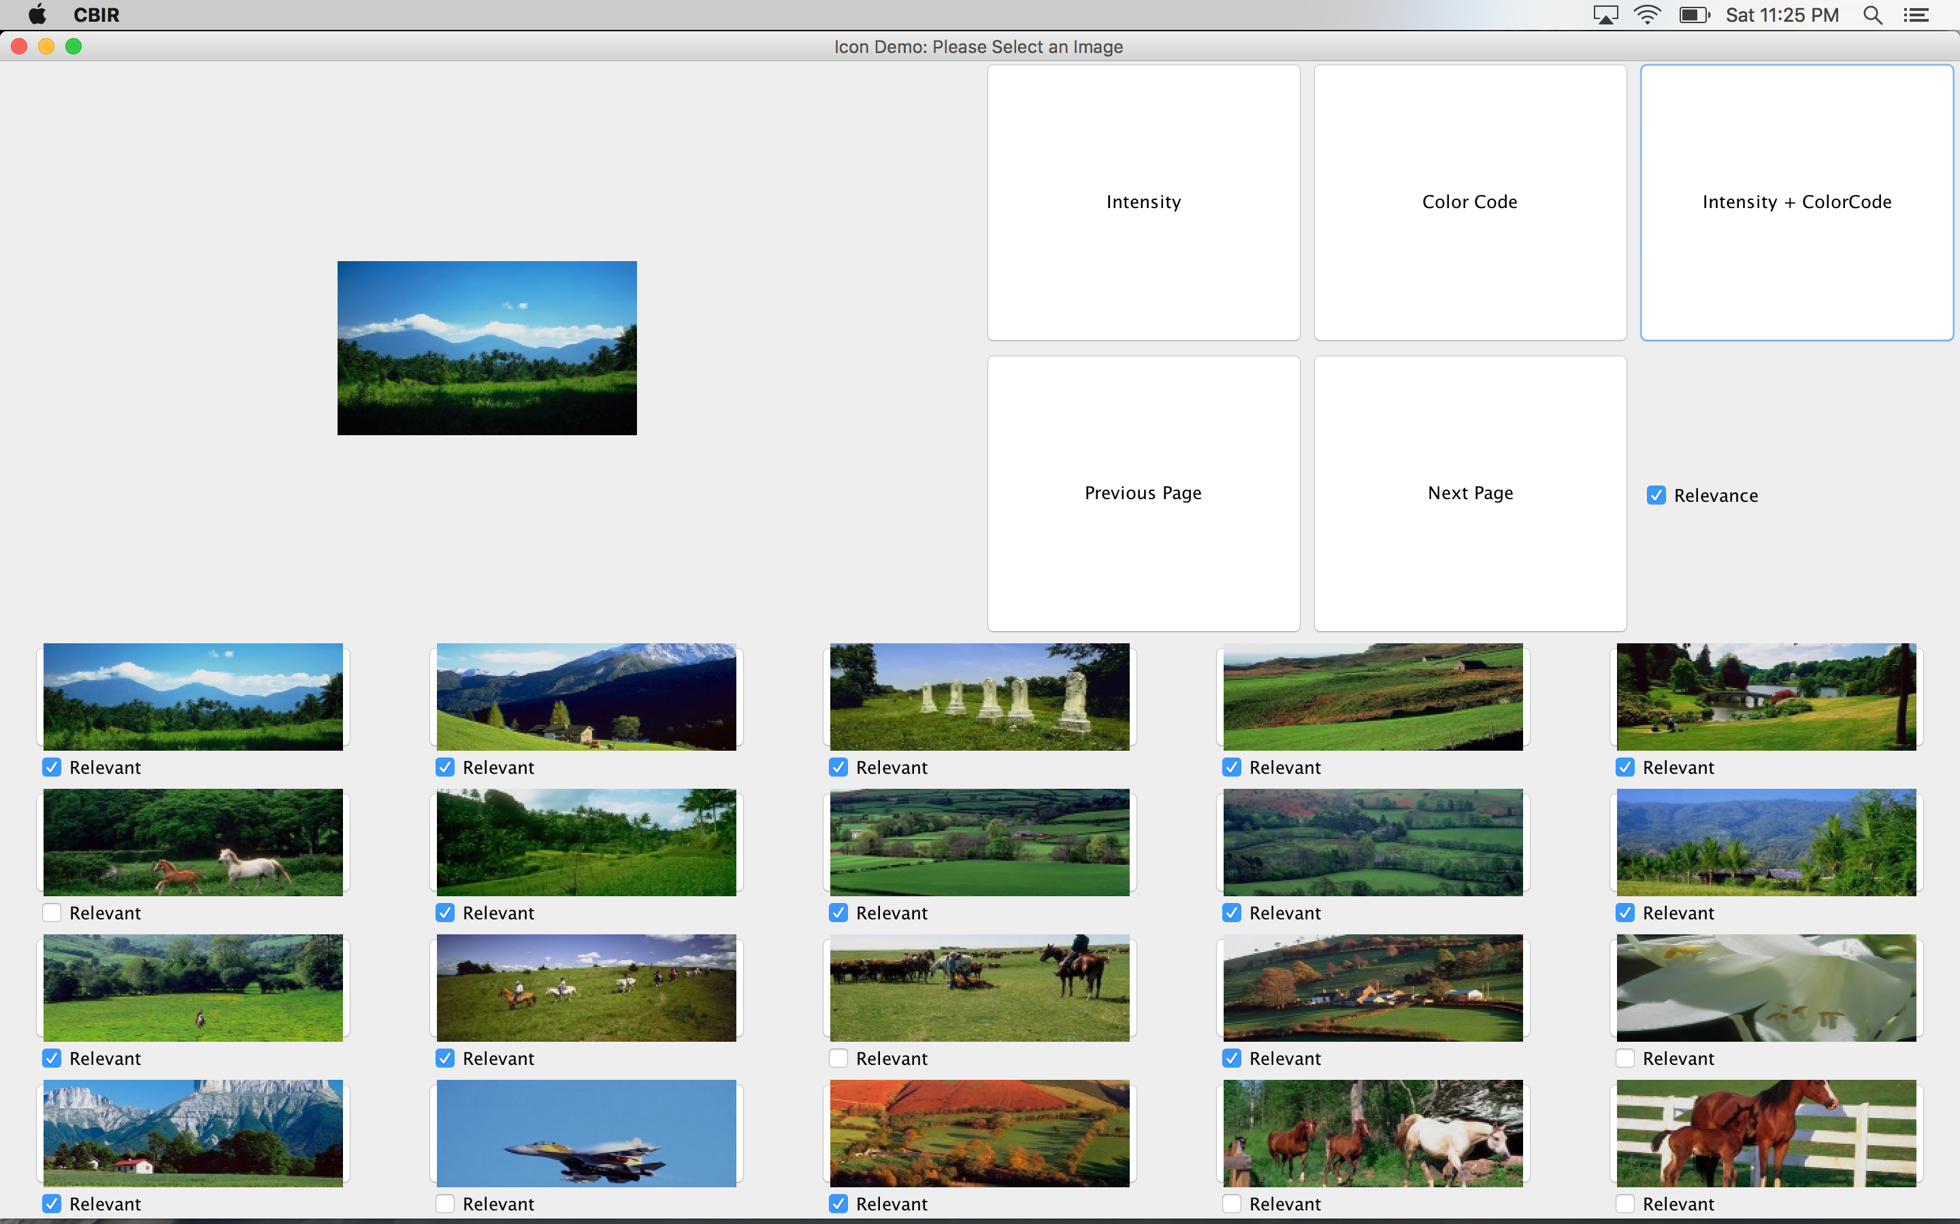

**Further Analysis:**

Similarity between Relevance Feedback algorithm and Relevance Feedback Framework:

* Both of the approaches rely on human feedback
* They use image relevance as the main attribute for retrieving images.
* The features weights are automatically calculated in both of the approaches.
* They take feedback from humans which mean the images that humans find relevant to each other are considered for retrieving other similar images.
* Both approaches try to fill the gap between high level and low level features using user feedback on retrieved images.
* The image weights are dynamically updated.

Difference between Relevance Feedback algorithm and Relevance Feedback Framework:

* Relevance feedback Framework uses more features than Relevance feedback algorithm.
* Relevance feedback algorithm uses intensity and Color code features whereas Relevance Feedback framework also uses color, texture and shape feature.
* RF algorithm combines Intensity and Color code histograms to build a feature matrix whereas RF framework uses intensity, color code histograms and more methods to calculate each feature.
* These feature in RF framework are assigned different weights using Intra and Inter normalization procedures whereas RF algorithm uses Gaussian normalization approach.